**Design Thinking Stages Final Documentation**

**Group 07 – QuadThink**

**DOST-STII CitiSense**

Team Leader:

Marabi, Mark Lyster C.

Members:

Bernal, Lorenzo Emil S.

Cabangcala, Gabrielle J.

Lazaro, Luis Lorenzo

Systems Analysis & Detailed Design

MSYADD1

SF231

Mr. Jose Eugenio L. Quesada

A.Y. 2025 - 2026

1st Term

**Stage 1: Empathize**

**Introduction**

In the first stage of Design Thinking, our group, QuadThink, aims to achieve the goal of gaining a deeper understanding of the needs, wants, and circumstances of our client, together with the customers. In order to achieve this goal, our group conducted several online interviews via Zoom together with our client and the IRAD (Information Resource and Analysis Division) department of DOST-STII (Science and Technology Information Institute). This allowed us to directly gather relevant ideas even though we are not physically present in various meetings.

Whenever our group meets with the client and customers, we ensure that we gather correct and accurate information regarding their concerns and perspectives to provide a suitable solution for their challenges. Our group made use of various guidelines that were presented during class discussions in order to stay right on track. Moreover, our group made use of the 5 Whys to dig into the main cause of the problem. In addition, our group also asked open-ended questions to gather more relevant information about the problem, as well as to document the client and customers' detailed and authentic responses. The recorded sessions have helped our group to create customer personas that match the perspectives of the customers involved in order to visualize and organize the information gathered. Lastly, our group made an empathy map and pain-gain analysis to recognize their behaviors, feelings, and pinpoint their frustrations and opportunities for development.

With the help of these activities, our group was able to better understand the issues and problems of the IRAD department and to prepare for addressing all of their needs in the next steps of the design thinking process.

**Interview with the Client**

**(New 5 whys):**

o Why is the sharing of ideas across teams challenging with your current system?

▪ “We don’t have a system.”

o Why don’t you have a system?

▪ “Well new, di sya new pero how can i say it, it's not common for government agencies to analyze sentiments or ung comments. It's not common for agencies to analyze deeply ung mga text data.”

o Why is it not common?

▪ “So ai is new not everyone, not all agencies can adjust or adapt with AI. Advent din talaga ng AI yung trigger nyo.”

o Why can’t they adapt/adjust with ai?

▪ “Of course, the limitation of resources that includes technical skills. Without APC mahihirapan kami i-build yan.”

o Why is there a limit of resources?

▪ “Limitation on resources? Budget noh? Ano bang klaseng resource? Human resources? Financial resources? If we limit the resources to technical skills? Mas madali, or budget wise kasi, poor answer kasi yun kapag wala kang budget eh. Sa limitation of resources siguro (technical skills) and then yung limitation na yon ai is fairly new. Advent ng ai siguro, yung limitation natin sa skills inhouse is dahil very new pa yung ai.”

**Open-ended Questions**

o What do you think a sentiment analysis tool would do to assist your IT team in decision-making or service improvement?

▪“Much faster processing time, with better, faster processing data, faster recommendations. Service would improve service based on the data if it is faster.”

o Have you tried using similar technologies or tools in the past? If so, what worked and what didn’t?

▪ “None, manual.”

o What does a successful outcome for this project look like from your perspective?

▪ “A working model, with a 70% accuracy for the system. For organizational: we can tweak services to serve the needs of the client.”

o What concerns or potential risks do you think we should be mindful of when implementing this project?

▪ “System security and data privacy since we are handling personal data, since it's client respondents.”

o How often would you like to review progress, and what from should those updates be?

▪ “Best is quarterly, in terms of reports and presentation.

**Customer Personas**

**Customer**: Arjay Escondo

**Biography**: Arjay Escondo is a data analyst who evaluates the performance of DOST STII IRAD’s research programs by cleaning data, analyzing feedback sentiments, and creating visual reports manually.

**Motivations**: 1. To make our work easier and faster, 2. To deliver more accurate insights, 3. To automate current workflow

**Goals**: 1. Ensure consistency among reports, 2. Save time and effort of our people, 3. Automate sentiment classification

**Frustrations**: 1. Manual work takes too long, 2. Prone to human errors, 3. Overwhelmed by large data volumes

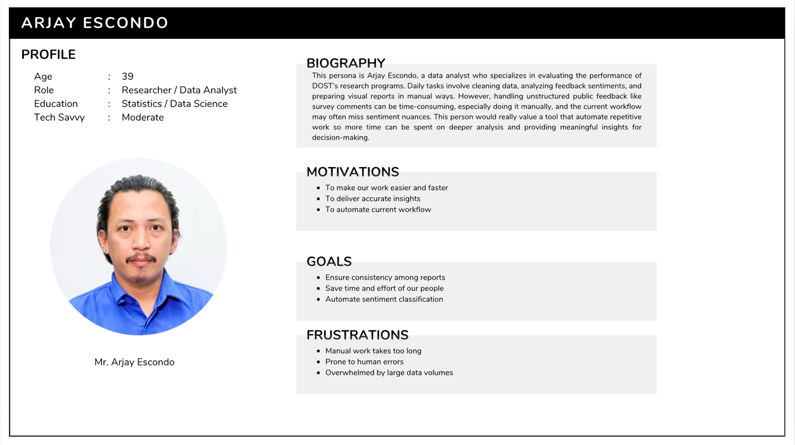

**Customer**: Chester Francisco

**Biography**: Chester Francisco is a Senior Research Specialist in Management Information Systems at DOST-STII who ensures digital platforms run smoothly and securely so staff can work efficiently without technical disruptions.

**Motivations**: 1. To automate current workflow, 2. To improve operational efficiency, 3. To support data-driven decision-making

**Goals**: 1. Ensure seamless integration of CitiSense into existing DOST systems, 2. Maintain system stability and security, 3. Provide reliable tech support for staff using the tool

**Frustrations**: 1. Inefficient manual processes, 2. Slow turnaround of data reports, 3. Frequent human errors in data handling

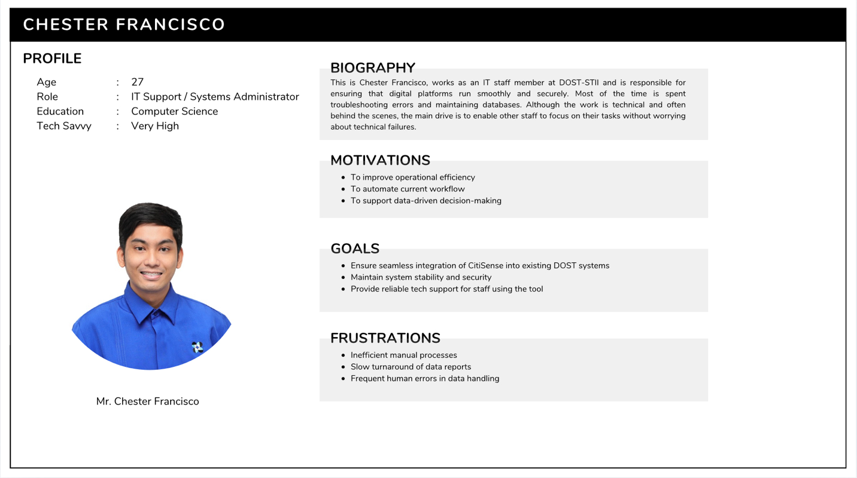

**Empathy Map**

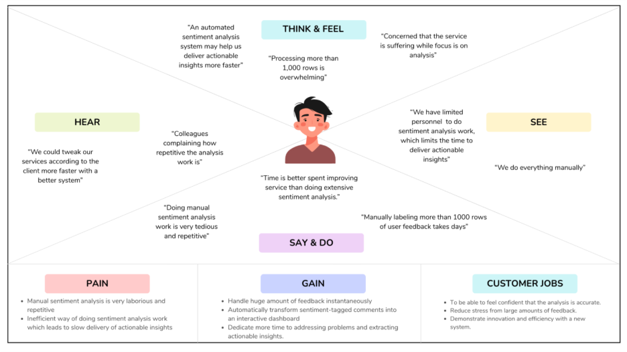

**Stage 2: Define**

**Introduction**

For the second stage of the design thinking process, our group utilized all the information gathered during the first stage, Empathize, where we conducted several interviews with our client and customers. Utilizing all the collected information, our group carefully analyzed the perspectives, insights, and challenges of each person involved in this project in order to determine a clear point of view (POV) and problem statement. Establishing a proper and organized structure was crucial for our group since it would serve as a guide in preparing for the other stages of the design thinking process.

The first stage of design thinking generated a huge amount of information with the use of interviews and user experiences, and with this, it is necessary for the team to organize and synthesize the findings. This will allow the team to categorize all the user experiences and challenges. With the help of this process, we transformed all the gathered information into structured and organized insights, ensuring clarity and harmony among the team members.

**Clustering Problem Ideas**

As you can see in this figure, our group lists challenges with the current manual sentiment analysis of the DOST-STII IRAD department and categorizes them into four main categories, namely: Inefficiency Problems, Technology Gaps, and Time Optimization. These categorizations were consolidated through a group discussion in order to highlight the root causes and issues that affect the efficiency, innovation, and productivity of the said department.

**Inefficiency Problems**

The current manual sentiment analysis of the DOST-STII IRAD department consumes a lot of time and effort to execute the process effectively. This inefficiency affects productivity and makes it difficult for data analysts to handle and analyze large amounts of data. In addition, there is a high chance of uncertainty for the accuracy of results, and this may lead to doubts about the reliability of the insights that came from the feedback. Moreover, these challenges limit the ability of the department to make haste for data improvements.

**Technology Gaps**

The third cluster of issues is about the absence of technology and system integration. Currently, the DOST-STII IRAD department has no automated system for its sentiment analysis, for them to upload and analyze feedback, which then results in a delayed or slower processing of sentiments with several inconsistencies. There is a lack of tools for properly managing and processing large amounts of data, which leads to difficulty in making scalable operations. Furthermore, the absence of an integrated visualization dashboard also prevents users from easily identifying and analyzing trends and interpreting results accurately and strategically.

**Time optimization**

The manual sentiment analysis process creates an excessive amount of workload for employees, specifically when it comes to handling large amounts of feedback from people who experience the services of DOST-STII. Tasks such as reading, categorizing, and interpreting customer feedback are some of the primary examples of repetitive work that DOST-STII employees face every day. These tasks take up valuable time that could be used for other priorities and innovations.

**Problem Statements**

1. Doing manual sentiment analysis work is tedious and repetitive
2. Data analysts could be doing a lot more tasks involving the betterment of the services rather than focusing much of their time on manual sentiment analysis.
3. There is a need for an automated sentiment analysis system that can handle both English and Tagalog languages.

**How Might We Questions**

After identifying the problem statements, our group then proceeds to create “How Might We” questions. These questions will turn the identified issues into new opportunities for innovation, guiding our group to generate effective and innovative solutions. The problem statements serve as a stepping stone for developing these types of questions and to ensure that our group is aligned with the needs of our client and customers.

Here are the How Might We questions that our team initiated:

1. How might we reimagine helping IRAD employees to transform raw feedback data into actionable insights that directly improve service delivery automatically?
2. How might we reimagine helping IRAD employees in streamlining their current manual sentiment analysis workflow?
3. How might we reimagine enabling IRAD employees to deliver greater value by focusing more on improving service delivery, instead of spending excessive time on manual sentiment analysis?

**Conclusion**

There is a need for improvement regarding the manual process of the sentiment analysis of the DOST-STII IRAD department. The clustered problems identified in the paper highlight the need to have an automated sentiment analysis system. In order for the team to be aligned and guided, we formulate clear problem statements. The “How Might We” questions serve as a guide to create possible innovative solutions that should address efficiency and accuracy of the process. In addition, implementing automation and visualization tools would reduce employee workload and improve the accuracy of insights. To sum it all up, the analysis emphasizes the importance of integrating and adopting technology-driven solutions in order to enhance productivity, innovation, and service quality within the department.

**Stage 3: Ideate**

**Introduction**

At this stage of the design thinking process, our group gathered together to identify each of our own ideas to integrate into the website application. This stage allows us to combine different ideas and make sure that the goals of this project are met.

**Brainstorming Session**

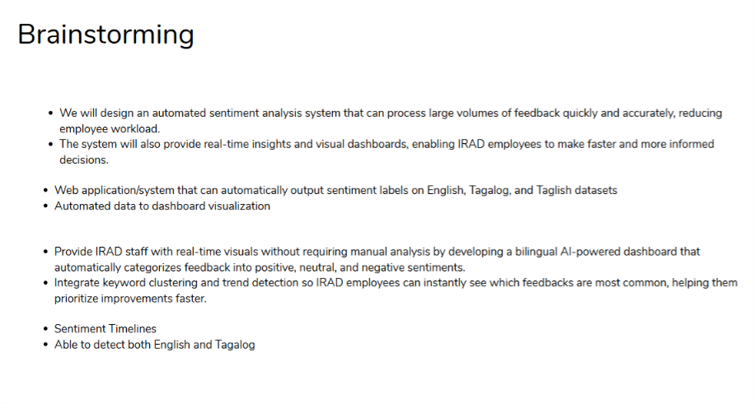

Our group gathered in an online meeting to discuss our opinions on addressing the client’s needs and solving challenges regarding their system.

**Crazy 8**

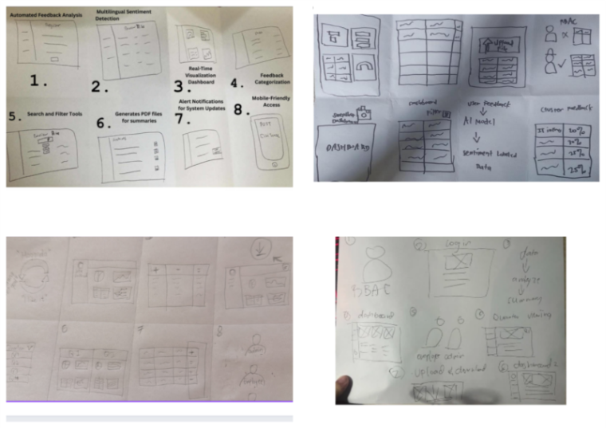

In this session, each member contributed their ideas for the making of the Crazy 8. We included features that we want to integrate in the website application and explained what each drawing represents.

**Post-It Voting**

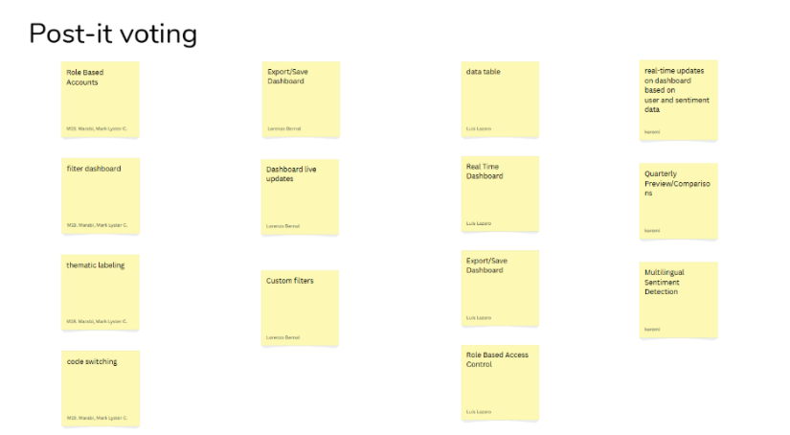

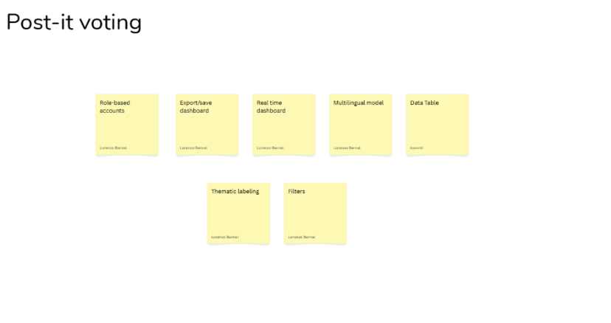

After discussing and finalizing the Crazy 8, our team, Quadthink proceeded with a post-it voting assessment. Each member had an opportunity to vote for the ideas that were most innovative and aligned with the project’s objectives.

**Feasibility-Viability-Desirability Analysis**

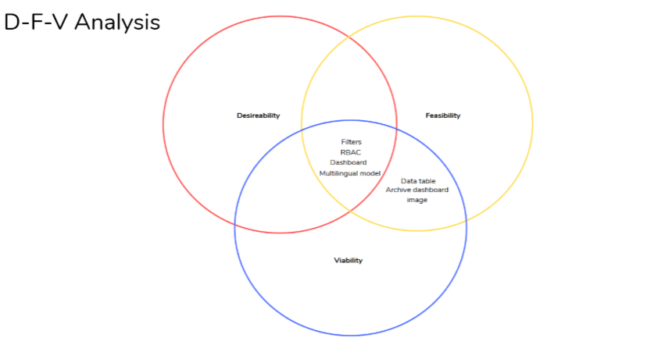

After the post-it voting, our group proceeded with the Feasibility-Viability-Desirability Analysis to further evaluate the selected ideas. By utilizing this framework, our group was able to narrow down our options and prioritize ideas that demonstrated the strongest qualities for the website application.

For the functionality that encapsulates the three categories of the Venn diagram, we have:

* Filters
* Role-Based Access Control
* Dashboard
* Multilingual AI Model

These are the functionalities that our customers desire most, are feasible with current technologies, and are viable as they provide long-term value for our clients in the context of service delivery.

As for Feasible and Viable only, we have:

* Data Table
* Generate Reports

These are only at the feasible and viable level, as these functionalities can be done outside our system, such as editing the data in Google Sheets. As for Generate Reports, our clients can make inferences and generate reports according to what they are currently seeing in the dashboard and data table outside of our proposed system.

**Stage 4: Prototype**

**Introduction**

At this stage of the Design Thinking process, our group, QuadThink, focused on creating prototypes that demonstrate the core features of our system solution. Each prototype highlights how users will interact with the system to ensure usability and efficiency. Our group conducted several meetings with our clients to demonstrate and simulate real user experiences. Furthermore, through this scenario, we were able to visualize how our system could operate in practice. Overall, these prototypes will serve as a foundation for future development, providing our group with a clear direction for enhancing the system's functionality.

**Storyboard of the current manual workflow of our client (to visualize what our system aims to solve, which is the automation of the manual sentiment analysis workflow):**

**Storyboard for our proposed system, along with the benefits of using it:**

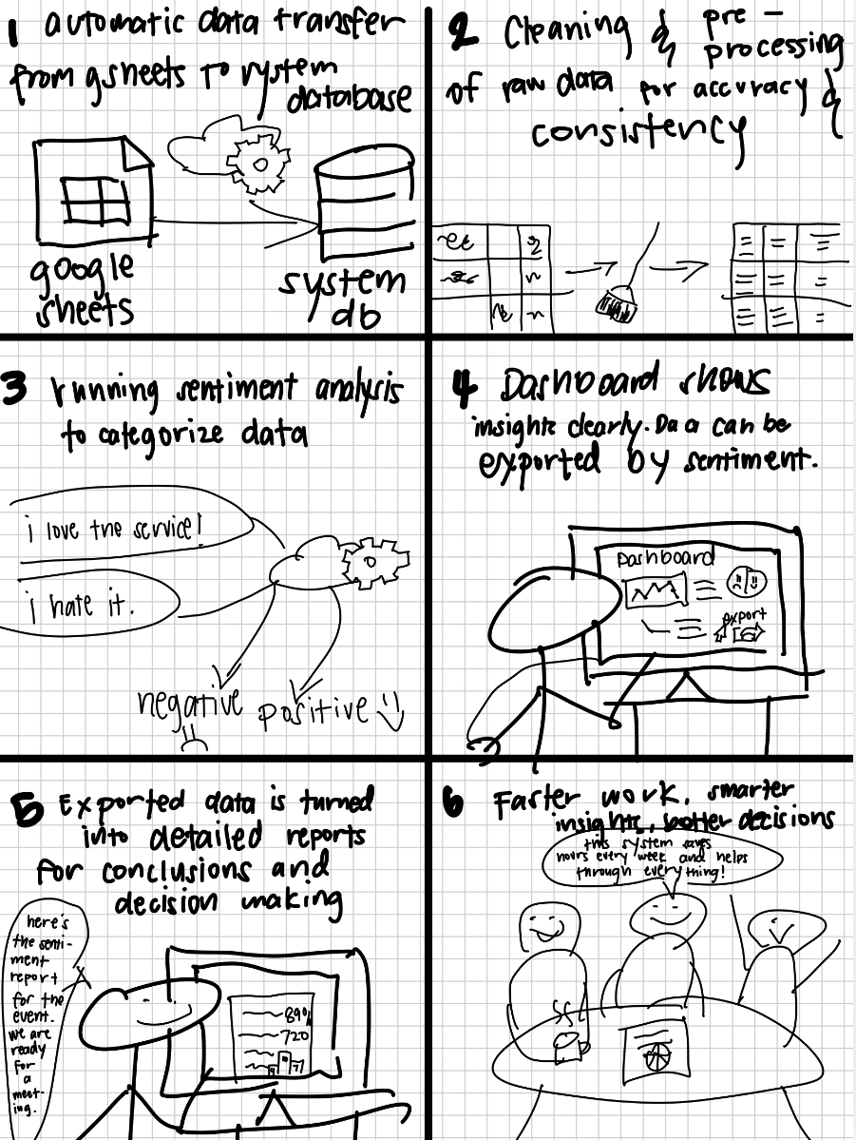

**Prototype**

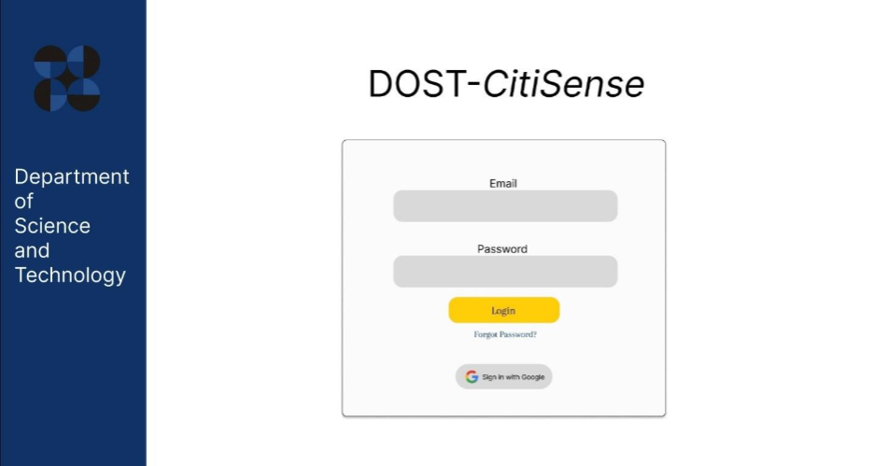

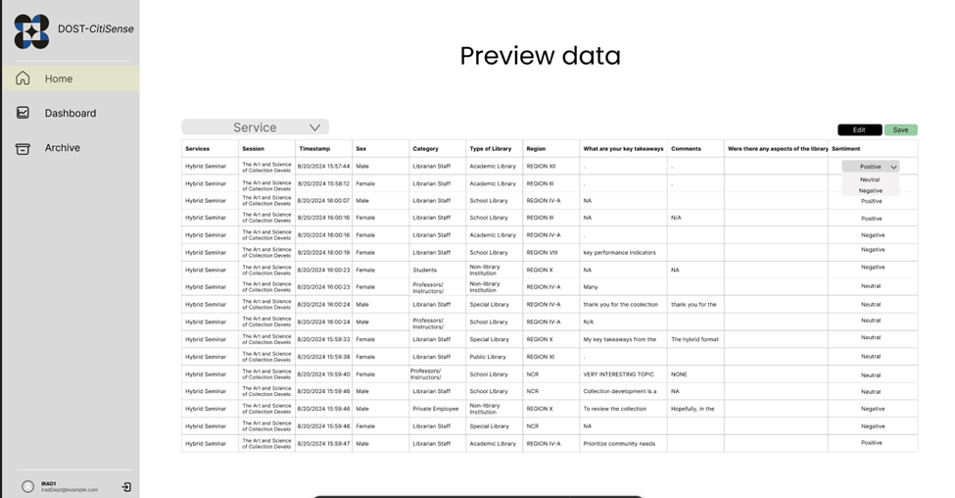

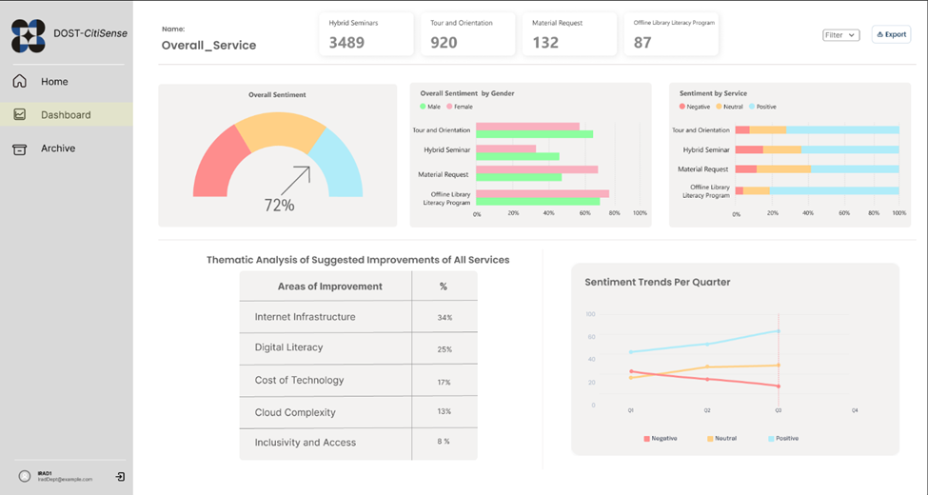

**Stage 5: Testing**

**Introduction**

For the fifth stage of the Design Thinking process, our group, QuadThink, presented the prototype of our automated sentiment analysis system to our client for testing as well as feedback. Our group demonstrated how to use the system, which includes properly addressing the challenges of the manual sentiment analysis system, such as providing a visualization dashboard for feedback analysis. The prototype is carefully designed to align with the goals and objectives of our client and was guided by references from tools to cater to the needs of the client. Aside from the minor adjustments to the system, the client appreciated the overall functionality of the system and is positive that this project would be beneficial for the decision-making process of the DOST-STII IRAD department.

Meeting Link: [video1342409374.mp4](https://asiapacificcollege-my.sharepoint.com/:v:/g/personal/lsbernal_student_apc_edu_ph/EVPCA99tsIJPlur25hlTVPwBrNRvHrlWSRndrXpgONy-Lg?nav=eyJyZWZlcnJhbEluZm8iOnsicmVmZXJyYWxBcHAiOiJTdHJlYW1XZWJBcHAiLCJyZWZlcnJhbFZpZXciOiJTaGFyZURpYWxvZy1MaW5rIiwicmVmZXJyYWxBcHBQbGF0Zm9ybSI6IldlYiIsInJlZmVycmFsTW9kZSI6InZpZXcifX0%3D&e=Bb62L1)

Client Comment:

* The client noted that they will add a column in the Google Sheets source data to reflect quarterly information. Once this column has been included, our group, QuadThink, will receive the updated data, enabling the system to incorporate a new filter in the dashboard for quarterly analysis alongside the existing per-service filter (e.g., January, February, March – Quarter 1). A total of 4 Quarters for the filter.

